BOXER-6840-CFL
Fanless Embedded Controller with
8th /9th Gen. (Coffee Lake) Intel® Processor

Engineering Specification

Rev. 0.1
2021/05/10

PM | David
PM | Ray
RD | H/W | Howard
RD | S/W
RD | ME | ET
RD | QE
RD | DS
Sales
Revision History

Revision History
Rev | Brief Description of Changes | Date of Issue | Author(s)
0.1 | Original release | 2020/05/10 | David

Feature
- High Computing Power
- Intel Coffee Lake-S LGA 1151 Desktop Processor
- Air Duct Design for Acceleration Card Thermal Dissipation
- Special Expansion Card Fix Structure for High Level Anti-Vibration
- Support PCIEx16 and PCIEx4
- Single Power Input (for both system & GPU)

Diagram

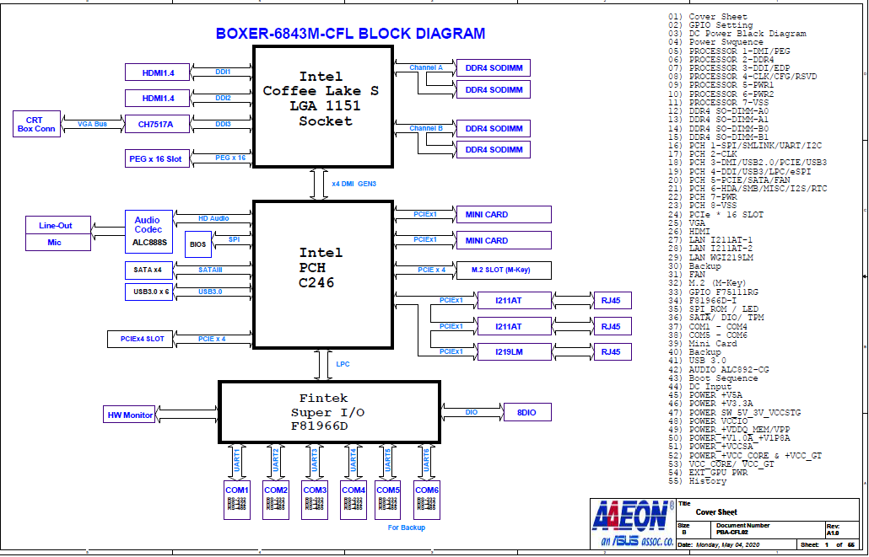

SPECIFICATIONS

Main Specification

Engineering Specification
Product Name | BOXER-6840-CFL
Construction | Rugged Aluminum Alloy & Cold Roll Steel Chassis, IP50 Compliant  Optional for FAN
CPU Board | PBA-CFLS02
Processor | Intel® Xeon® E-2124G  Intel® Core™ i9-9900T  Intel® Core™ i7-8700T  Intel® Core™ i5-8500T  Intel® Core™ i3-8100T  Intel® Pentium® G5400T  Intel® Celeron® G4900T  PS. Support max. TPD 71W Processor
PCH | C246
System Memory | DDR4 SO-DIMM socket x4 (double deck)  Supports max. 2666MHz up to 128GB  Support un-buffered and ECC / non-ECC type SODIMM
Display | HDMI x2  Support Dual Independent Display, 4K Ultra HD displays
Storage | 2.5” SATA Drive Bay x2  mSATA x1 (optional)  M.2 2280 NVMe SSD slot x1
I/O panel | HDMI x2  RJ-45 x3 for GbE LAN (Intel I211-AT x2, Intel I219-LM x1)  Audio (Mic-in, Line-out)  USB 3.2 Gen1 x6  DB-9 x4 for RS-232/422/485 with automatic flow control  3 pin DC Power input x1 (+, - , GND)  Power ON/OFF switch x1  2 Pin Remote power on/off connector  Reset switch
Expansion Slots | BOXER-6840-CFL-A1  Full-size Minicard x1 (PCIE + USB), support PCIE Gen 1  Half-size Minicard x1 (PCIE/mSATA, default PCIE+USB), support PCIE Gen 1  SIM Card Slot x1  M.2 M key (2280) x1 (PCIEx4, Gen3)  PCIEx4 slot x1 (Gen3)  PCIEx16 slot x1 (Gen3)

Expansion Slots | BOXER-6840-CFL-B1 ( BOXER-8332AI)  Full-size Minicard x1 (PCIE + USB), support PCIE Gen 1  Half-size Minicard x1 (PCIE/mSATA, default PCIE+USB), support PCIE Gen 1  SIM Card Slot x1  M.2 M key (2280) x1 (PCIEx4, Gen3)  PCIEx4 slot x1 (Gen3)  Built in Nvidia Tesla T4 x1
Reserved Connector | Internal, 8bit DIO x1  Internal, USB 2.0 x4  Internal, LPC x1  Internal, Secondary System Fan Connector x1
Fan | Primary System Fan Connector x1
Indicator | System Power LED x1 (Green)  Storage Active LED x1 (Red)
Mounting | Wallmount
Power Supply | DC In 12~24V with 3-pin terminal block
Dimensions (W x H x D) | BOXER-6840-CFL-A1: 220 x 150 x 320 mm  BOXER-8332AI: 220 x 150 x 280 mm
Net weight | TBD
Gross weight | TBD

Environmental Specifications

Operating temperature | BOXER-6840-CFL-A1  -4°F~149°F (-20°C ~ 65°C) with 0.5m/s airflow  BOXER-6840-CFL-B1 (BOXER-8332AI)  32°F ~ 113°F (0°C ~ 45°C) with 0.5m/s airflow
Storage temperature | -49°F~176°F (-45°C ~ 80°C)
Storage humidity | 5 ~ 95% @ 40°C, non-condensing
Vibration | SSD: Random, 5Grms, 5~500Hz
Shock | SSD：50G @ wallmount, Half-sine, 11ms
Drop | 76 cm (1 Corner, 3 Edge, 6 Surface)
EMC | CE/FCC class A

OS Support

Operation System | Support | Notes
Windows 10 | V | 64bit
Linux | V | Ubuntu 20.04.1

Ordering Information

P/N | Description
BOXER-6840-CFL-A1-1010 | HDMI*2. USB3.2 Gen1*6. COM*4.LAN*3. PCIEX16+PCIEx4
BOXER-6840-CFL-B1  (BOXER-8332AI) | HDMI*2. USB3.2 Gen1*6. COM*4.LAN*3. PCIEx4.Tesla T4*1

Appearance
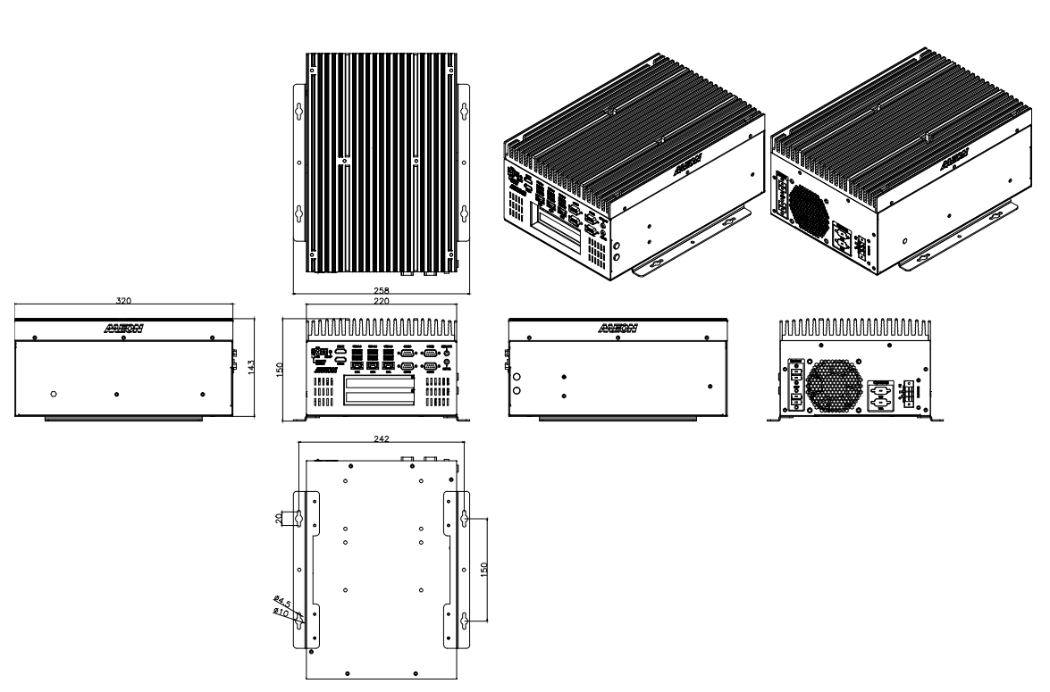
BOXER-6840-CFL

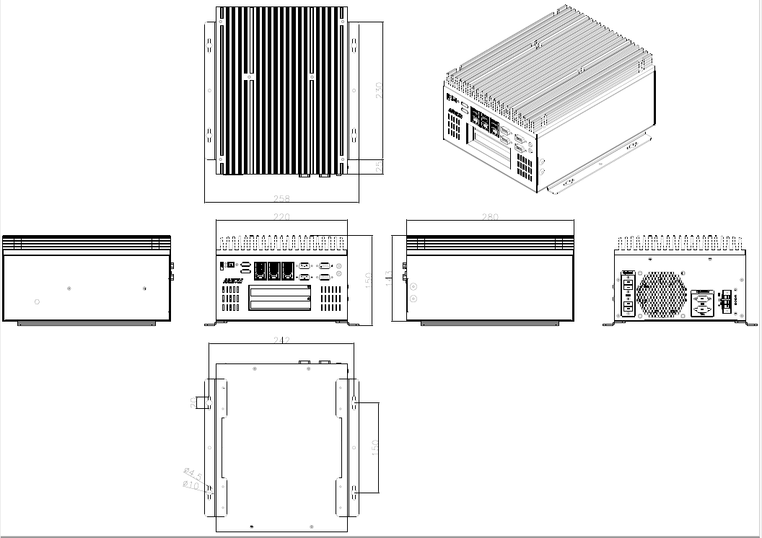
BOXER-8332AI

